Diagnosing Tick-Borne Illness
A wet-lab simulation

Tick-borne diseases are epidemiologically and clinically complex. Accurate and sensitive diagnostic tools are key to patient recovery. Diagnostic tests typically measure the presence of a specific pathogen either indirectly by screening for the patient’s immune response to the pathogen, or directly by screening for the presence of pathogen itself (or its genetic material). Throughout this investigation, you are presented with six patients and are asked to provide a diagnosis for each based on patient history, symptoms, and diagnostic test results.

Part 1: Patient histories
Each patient history provides background epidemiological information and patient symptoms. For EACH patient, provide a preliminary diagnosis (including the evidence that supports your diagnosis).

Patient A: A 37-year-old woman who enjoys walking her dog in the local dog-park each evening.
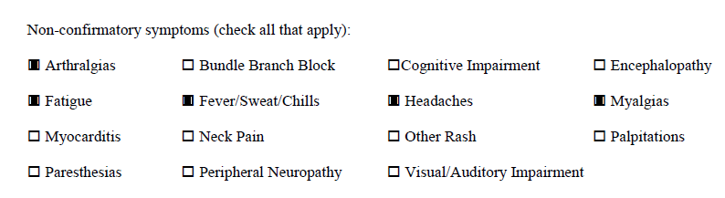
Patient B: Patient A’s 6-year-old Labrador retriever mix. He has seemed lethargic and has been limping on alternate legs for the past two weeks.

Patient C: A 44-year-old man who enjoys the outdoors went out on a winter hike on a warm day following a snowfall, and has been feeling ill.
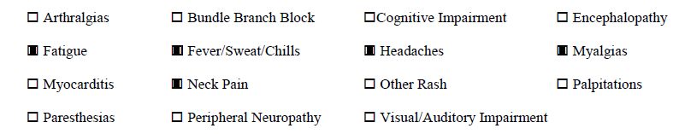
Patient D: A 14-year-old girl who has just learned her best friend from summer camp in Minnesota has been diagnosed with Lyme disease. Although the disease is not transmitted through personal contact, she could have been exposed to other infected ticks while in the area and asks to be tested. She is asymptomatic.

Patient E: A 23-year-old landscaper who is often asked to mow areas with tall grasses.
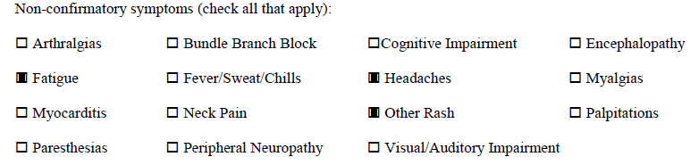
Patient F: A 28-year-old graduate student who attends school in upstate New York.
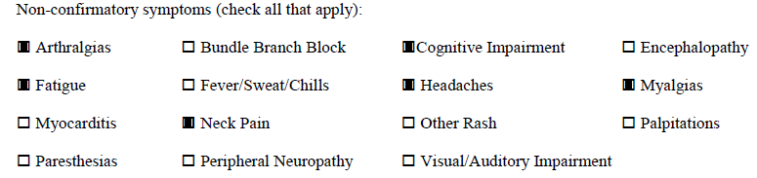

Part 2: Diagnosing using ELISA
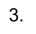
ELISA (Enzyme-Linked Immunosorbent Assay) detects the presence of antibodies produced by the patient in response to a pathogen. They are typically performed on a microtiter plate so that tests can be replicated easily. The diagram below illustrates how molecules interact to demonstrate patient exposure to a pathogen.

Step 1: Addition of antigen (or entire pathogen) under consideration to well of microtiter plate.
Step 2: Addition of patient sample. If antibodies are present, they’ll bind to antigen.
Step 3: Addition of secondary antibody. If patient antibodies are present, the secondary antibodies (with their linked enzymes) will bind.
Step 4: Addition of substrate. The linked enzyme will convert colorless substrate to a colored product.
A positive test (illustrated by a color change) indicates that the patient is producing antibodies to the pathogen being assayed. Darker colors indicate higher patient antibody titers (a stronger immune response).

Tick Panel ELISA Protocol:
Note: This is a simulation. You are not using actual pathogens!

Beware of false positives. The key to performing a successful ELISA is careful labelling. Make sure you are being careful about where you load reagents, which reagents you add and when, and be extra careful to change pipets when it’s appropriate to do so.

Your microtiter plate should be organized according to the diagram below.

 | 1 | 2 | 3 | 4 | 5 | 6 | 7 | 8 | 9 | 10 | 11 | 12
A | 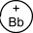
B
C
D
E
F
G
H

Rows A-C are reserved for B. burgdorferi. Rows E-G are reserved for R. ricketsii.
Column 1= + control
Column 2= - control
Column 3= Blank
Column 4= Patient A
Column 5= Patient B
Column 6= Patient C
Column 7= Patient D
Column 8= Patient E
Column 9= Patient F
Columns 10-12= Blank

Note: The wash step is eliminated in this simulation.

Addition of Appropriate Antigen
- Add 1 drop of B. burgdorferi antigen to Columns 1, 2,4→9 in rows A, B, and C.
- Add 1 drop of R. rickettsii antigen to Columns 1, 2,4→9 in rows E, F, and G.

Addition of Controls and Patient Antibodies
- Add 1 drop of Bb positive control antibodies to wells A1→C1.
- Add 1 drop of Bb negative control antibodies to wells A2→C2.
- Add 1 drop of Rr positive control antibodies to wells E1→G1.
- Add 1 drop of Rr negative control antibodies to wells G2→E2.
- Add 1 drop of Bb-specific Patient A antibodies to wells A4→C4 and Rr-specific antibodies to wells E4→G4.
- Add 1 drop of Bb-specific Patient B antibodies to wells A5→C5 and Rr-specific antibodies to wells E5→G5.
- Add 1 drop of Bb-specific Patient C antibodies to wells A6→C6 and Rr-specific antibodies to wells E6→G6.
- Add 1 drop of Bb-specific Patient D antibodies to wells A7→C7 and Rr-specific antibodies to wells E7→G7.
- Add 1 drop of Bb-specific Patient E antibodies to wells A8→G8 and Rr-specific antibodies to wells E8→G8.
- Add 1 drop of Bb-specific Patient F antibodies to wells A9→C9 and Rr-specific antibodies to wells E9→G9.

Addition of Secondary Antibodies
- Add 1 drop of secondary antibodies to all wells with reagents: A1→C1, A2→C2; A4→C4, A5→C5; A6→C6, A7→C7; A8→C8, A9→C9; E1→G3, E2→G2; E4→G4, E5→G5; E6→G6, E7→G7; E8→G8, E9→G9.

Addition of Substrate
- Add 1 drop of substrate to all wells with reagents: A1→C1, A2→C2; A4→C4, A5→C5; A6→C6, A7→C7; A8→C8, A9→C9; E1→G3, E2→G2; E4→G4, E5→G5; E6→G6, E7→G7; E8→G8, E9→G9.

Results and Discussion:

1. Record the color-changes that occurred in the diagram of the microtiter plate provided above. Which patient(s) tested positive for B. burgdorferi exposure? Which patient(s) tested positive for R. ricketsii exposure?

2. Did all patients who tested positive exhibit equally strong responses? What does this indicate about his/her infection?

3. Did the results you obtained match your predictions? Were you surprised by any of the results? Use specific examples in your response.

4. What should these individuals do to prevent future exposure to tick-borne illnesses?

5. Antibody tests like ELISA have greatly improved the ability of medical professionals to diagnose disease and are now a routine part of clinical practice. However, ELISA tests alone are often not considered to be definitive as they can produce both false positives and false negatives. What condition(s) could lead to a false positive result in an ELISA? To a false negative result? What other pieces of evidence should a medical professional consider when making a diagnosis?

Part 3: Confirmation of Diagnosis by Western Blot and PCR
Positive ELISA tests are confirmed using Western Blots. In a Western Blot, the presence of a particular protein is assayed by running a sample through a gel using electrophoresis and using protein-specific antibodies to highlight the proteins in question (in this case the particular antibodies that are produced in response to pathogens such as B. burgdorferi and R. ricketsii). To confirm infection with a tick-borne pathogen, patient samples are electrophoresed, then exposed to markers that are specific to patient antibodies. In this way, clinicians can assay the specific immune response a patient has mounted to the pathogen. They can use this information to either confirm or refute a diagnosis.

Alternatively, it may be possible to test for the presence of the pathogen itself. In this case, pathogen DNA is collected from patient samples and is used as a template for amplification via PCR (polymerase chain reaction), then visualized via electrophoresis. For this scenario, assume that patient samples have been used as a source for pathogen DNA, and that these samples have been amplified and electrophoresed. Use the ELISA results you obtained to analyze the PCR results shown below.

PCR Test for B. burgdorferi | PCR test for R. ricketsii
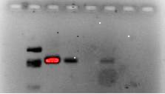 | 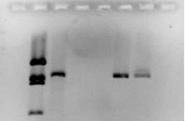
Lane 2: Size standard  Lane 3: B. burgdorferi positive control  Lanes 4-8: Patient samples | Lane 2: Size standard  Lane 3: R. ricketsii positive control  Lanes 4-8: Patient samples
In each test, two patients tested positive for the presence of either B. burgdorferi or R. ricketsii. Identify which patients are the most likely candidates for the positive results in EACH image. Include an explanation of your reasoning with your identification.

Diagnosing Tick-Borne Illness: Student Handout
Predictions, Data, and Analysis

1. Read the patient histories provided and fill in the chart below with your preliminary diagnoses.

Patient | Diagnosis | Evidence
A

B

C

D

E

F

2. Record your results by coloring or otherwise marking the diagram below.

 | 1 | 2 | 3 | 4 | 5 | 6 | 7 | 8 | 9 | 10 | 11 | 12
A
B
C
D
E
F
G
H
3. Which patient(s) tested positive for B. burgdorferi exposure? Which patient(s) tested positive for R. ricketsii exposure?

4. Did all patients who tested positive exhibit equally strong responses? What does this indicate about his/her infection?

5. Did the results you obtained match your predictions? Were you surprised by any of the results? Use specific examples in your response.

6. What should these individuals do to prevent future exposure to tick-borne illnesses?

7. Antibody tests have greatly improved the ability of medical professionals to diagnose disease and are now a routine part of clinical practice. However, antibody tests alone are often not considered to be definitive as they can produce both false positives and false negatives. What condition(s) could lead to a false positive result? To a false negative result? What other pieces of evidence should a medical professional consider when making a diagnosis?

8. In each of the PCR test results provided, two patients tested positive for the presence of either B. burgdorferi or R. ricketsii. Identify which patients are the most likely candidates for the positive results in EACH image. Include an explanation of your reasoning with your identification.

Teacher Notes
This lab can be done as a demonstration or a formal experiment if time allows. Alternatively, you may choose to assign some students to perform the B. burgdorferi test while others perform the R. ricketsii test on separate plates, have each group only do 1 replicant and share-out results to save reagents, or simply test for one pathogen to save prep time and supplies. The full procedure itself takes about 20 minutes to perform if lab stations are set up in advance for each group. More time will be necessary for pre- and post-lab discussion.

Pre-lab Preparation (30-45 min.)
Each lab group will need the following reagents in clearly marked 1.5- to 2.0-mL microcentrifuge tubes:

- 1.5 mL B. burgdorferi antigen--distilled water--marked Bb Ag
- 1.5 mL R.ricketsii antigen--distilled water--marked Rr Ag
- 1.0 mL B. burgdorferi positive control--0.1 N NaOH--marked + Bb
- 1.0 mL R. ricketsii positive control--0.1 N NaOH--marked + Rr
- 1.0 negative control--distilled water--marked - or neg
- 2.0 mL secondary antibody--distilled water--marked 2nd Ab
- 2.0 mL substrate--thymol blue*--marked sub
- For B. burgdorferi test
  - 1.0 mL Patient A serum--distilled water--marked A Bb
  - 1.0 mL Patient B serum--distilled water--marked B Bb
  - 1.0 mL Patient C serum--0.1 N NaOH (4g/L distilled water)--marked C Bb
  - 1.0 mL Patient D serum--distilled water--marked D Bb
  - 1.0 mL Patient E serum--distilled water--marked E Bb
  - 1.0 mL Patient F serum--pH 11 buffer--marked F Bb
- For R. ricketsii test
  - 1.0 mL Patient A serum--0.1 N NaOH--marked A Rr
  - 1.0 mL Patient B serum--0.1 N NaOH--marked B Rr
  - 1.0 mL Patient C serum--distilled water--marked C Rr
  - 1.0 mL Patient D serum--distilled water--marked D Rr
  - 1.0 mL Patient E serum--distilled water--marked E Rr
  - 1.0 mL Patient F serum--distilled water--marked F Rr
Other supplies include:
- Microtiter plate
- Permanent marker for labeling
- Disposable plastic pipets (19--one for each reagent) or micropipets with tips
- Microcentrifuge tube rack
- Safety goggles
* Phenolphthalein may be used as an alternate to thymol blue. If this substitution is made, an intermediate result is harder to obtain so substitute 0.1 N NaOH for the buffer for Patient F on the B. burgdorferi test. You may choose to substitute 0.1 N NaOH in lieu of buffer if none is available.
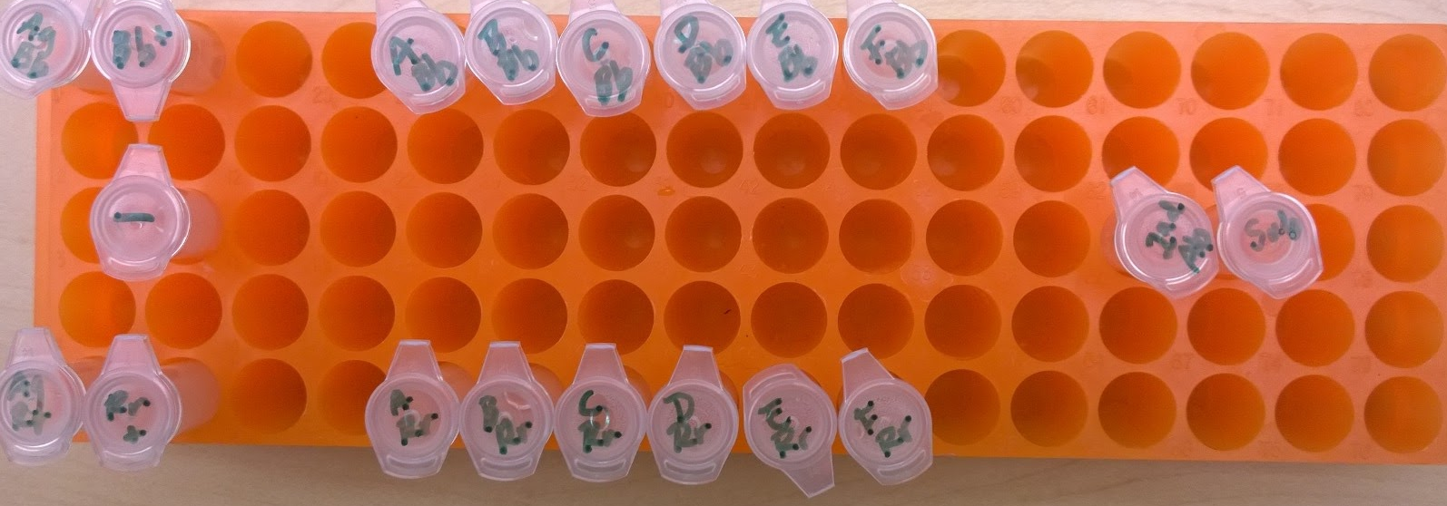
Results:
Patient | Diagnosis | Evidence
A | B. burgdorferi - neg  R. ricketsii- pos | Bb--no color change  Rr--dark blue
B | B. burgdorferi - neg  R. ricketsii- pos | Bb--no color change  Rr--dark blue
C | B. burgdorferi - pos  R. ricketsii- neg | Bb--dark blue  Rr--no color change
D | B. burgdorferi - neg  R. ricketsii- neg | Bb--no color change  Rr--no color change
E | B. burgdorferi - neg  R. ricketsii- neg | Bb--no color change  Rr--no color change
F | B. burgdorferi - weak pos  R. ricketsii- neg | Bb--lighter blue  Rr--no color change

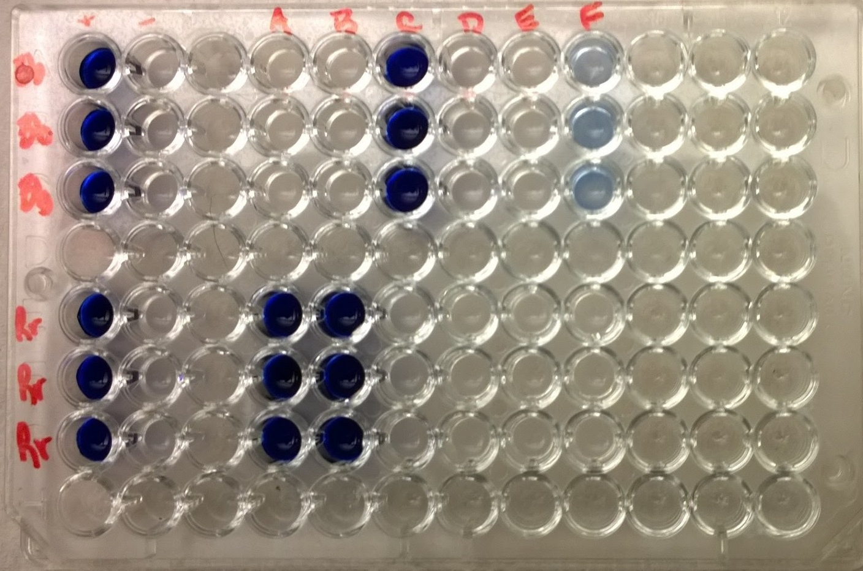

Hints for a successful test:
1. Have the students label all pipets clearly so as not to cross-contaminate reagents (the most common cause of a false positive). If using micropipets (use a volume of 30 microliters per drop), have students change tips before using a new reagent.
2. Have students label microtiter plates so as not to lose track of where to load reagents.
3. Before adding substrate, place microtiter plate on a light surface to better notice color change. Color change should be immediate.
4. You may consider making larger quantities of secondary antibody and substrate in conical tubes for each lab station to ensure lab groups don’t run out.

