Tick Matching Quiz Answer Key

Each (#) Photo has a Tick Species (Capital letter) and disease list (lowercase letter).

1. 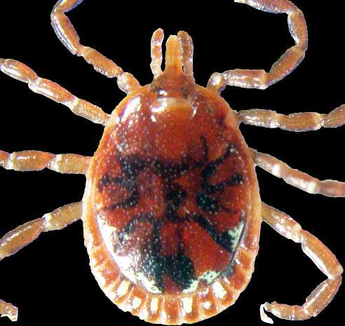
= E. Lone Star Tick Male
(Amblyomma americanum)
= a. Human Ehrlichiosis,
Tularemia, STARI,
& Heartland Virus

2. 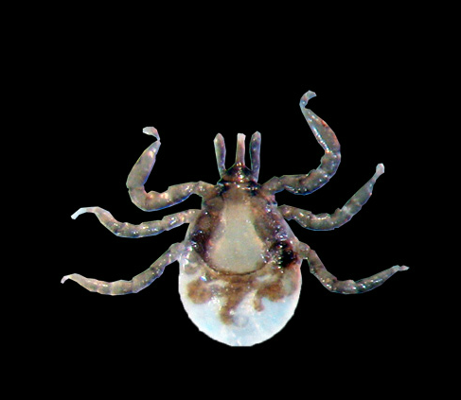
= H. Deer (Black-legged) Tick Larva
(Ixodes scapularis)
= e. none
(*larvae don’t transmit disease)

3. 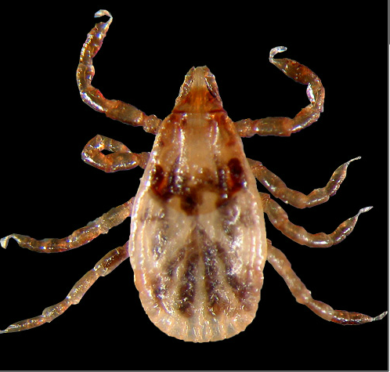
= A. Am. Dog Tick Nymph
( Dermacentor variabilis)
= c. RMSF
& Tularemia
= G. Brown Dog Tick Female
(Rhipicephalus sanguineus)
= d. Occasionally RMSF
4. 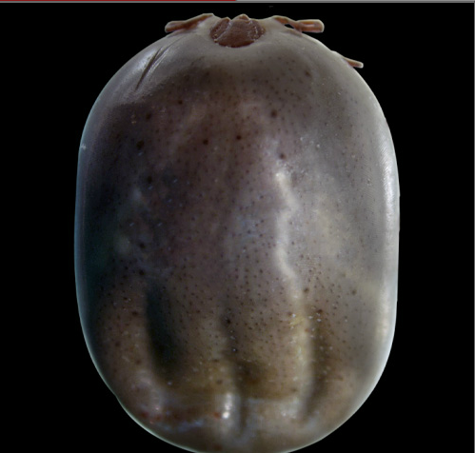
= D. Deer (Black-legged) Tick Female
(Ixodes scapularis)
= b. Lyme Disease
& Human babesiosis
& Human anaplasmosis
5. 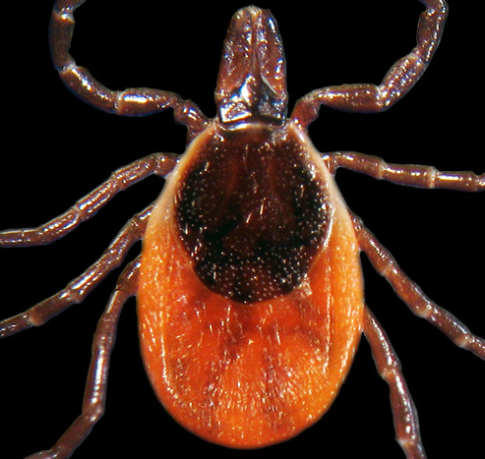

6. 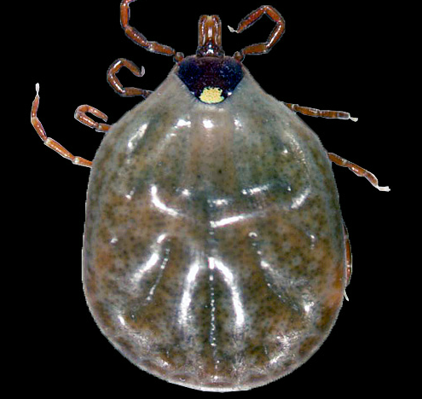
= B. Lone Star Tick Female
(Amblyomma americanum)
= a. Human Ehrlichiosis
Tularemia, STARI,
& Heartland Virus

7. 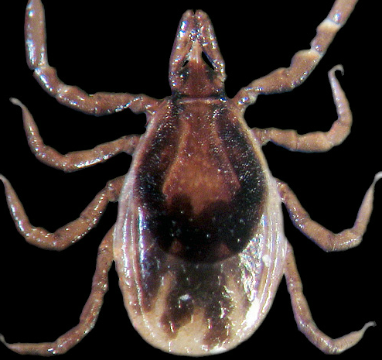
= C. Deer (Black-legged) Tick Nymph
(Ixodes scapularis)
= b. Lyme Disease
& Human babesiosis
& Human anaplasmosis

8. 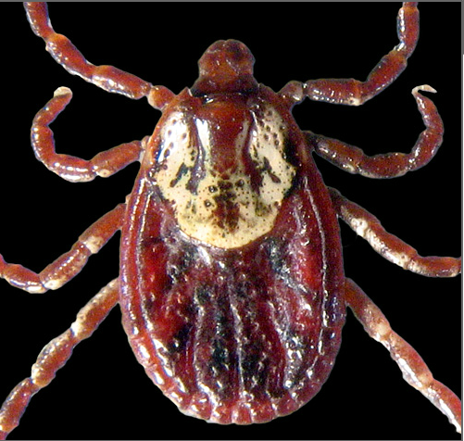
= F. Am. Dog Tick Female
(Dermacentor variabilis)
= c. Rocky Mtn. Spotted Fever
&Tularemia

