Matching Activity:

Match Each (#) Photo with the Correct Tick Species (Capital letter – use each only once) and correct disease list (lowercase letter – may be used more than once).

1. 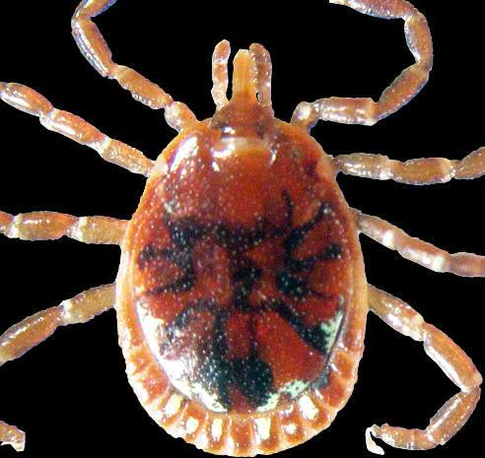 A. Am. Dog Tick Nymph a. Human Ehrlichiosis
Dermacentor variabilis Tularemia, STARI,
& Heartland Virus
2. 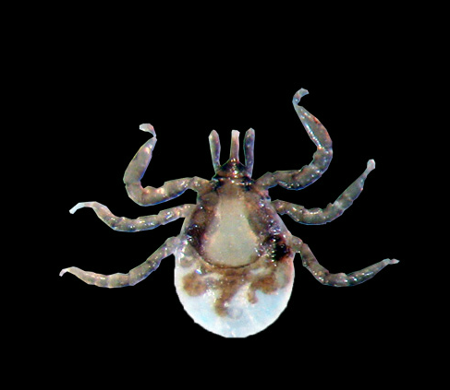 B. Lone Star Tick Female b. Lyme Disease
Amblyomma americanum & Human anaplasmosis
& Human babesiosis
3. 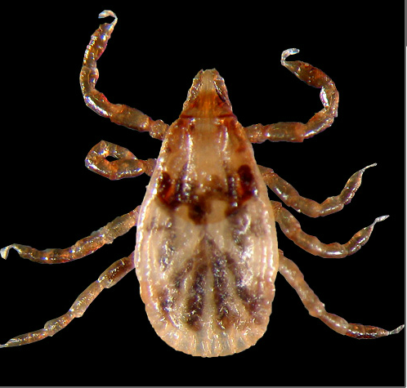 C. Deer (Black-legged) Tick Nymph c. RMSF
Ixodes scapularis & Tularemia

4. 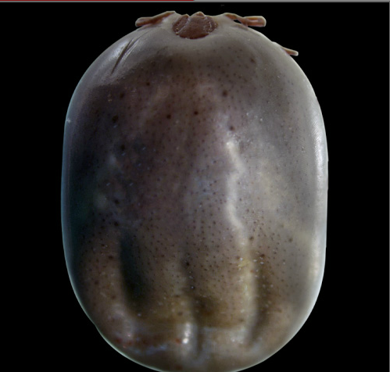 D. Deer (Black-legged) Tick Female d. OccasionallyRMSF
Ixodes scapularis

5. 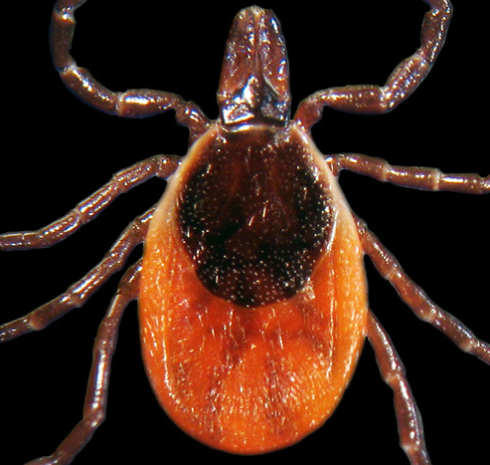 E. Lone Star Tick Male e. none
Amblyomma americanum

6. 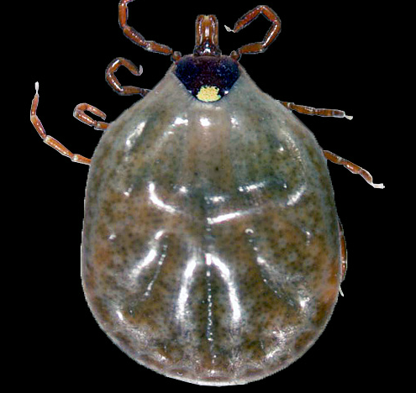 F. Am. Dog Tick Female
Dermacentor variabilis
7. 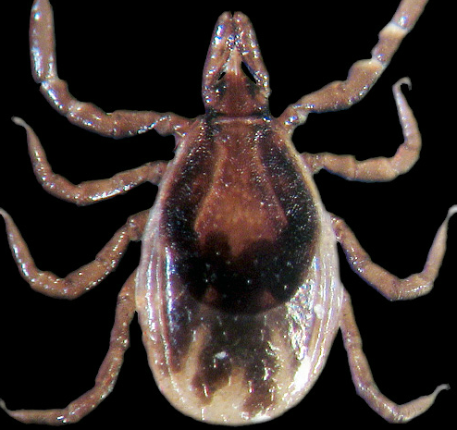 G. Brown Dog Tick Female
Rhipicephalus sanguineus

H. Deer (Black-legged) Tick Larva
Ixodes scapularis

8. 