Tick-Borne Disease Knowledge Assessment (Answer Key)

Matching:

1. Tick C. Type of Arachnid

2. Pathogen I. Disease-causing organism

3. Vector F. Passes a disease from one organism to another

4. Host B. Organism that a parasite feeds on

5. Ectoparasite D. Feeds on the outside of an organism

6. Endoparasite K. Feeds on the inside of an organism

7. Zoonosis J. Disease transmitted to humans from animals

8. Sentinel L. Provides a guard or warning for others

9. Endemic H. Normally found in or native to an area

G. Black-legged (Deer) Tick

- Lone-Star Tick

E. American Dog Tick

(* Not used: M. Brown Dog Tick)

10. 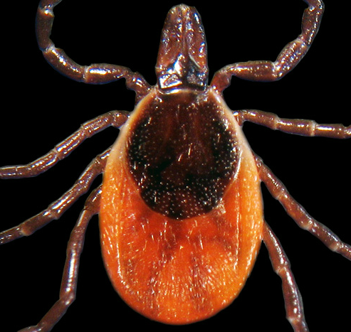

11. 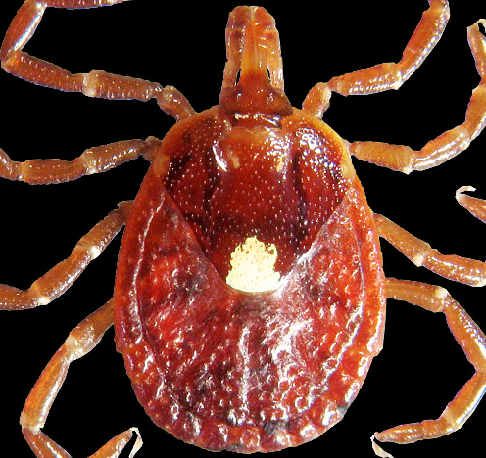

12. 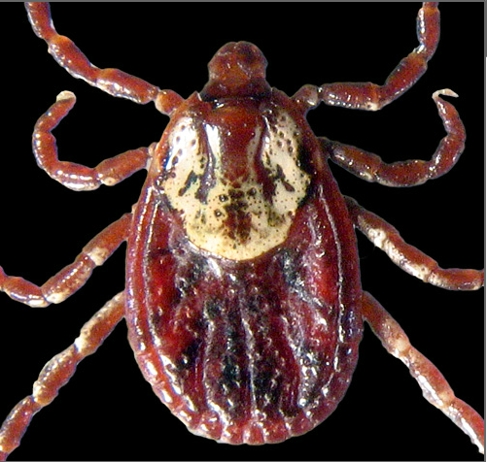

Multiple Choice:

13. What are life stages for a tick?

C) egg, larva, nymph, adult

14. How long does their life cycle take?

- 2-3 years

15. How do ticks find their hosts?

- sense heat or vibration and climb onto a host that brushes by them

16. Most tick-borne diseases are what type of pathogen?

- bacteria

17. What are typical symptoms of tick-borne disease?

- fever, headache and muscle aches, sometimes rash

18. How do doctors diagnosis a tick-borne disease?

D). All of the above (Blood samples, PCR, IFA, Western-Blot, and ELISA)

19. What should you do to prevent tick bites?

- stay out of long grass, wear long pants and use DEET

20. What is causing the increase in tick-borne diseases?

- increase in number of deer in the US

Short answer / Reflection Questions: (Answers will vary)

1. What is something you learned about ticks that you didn’t know before this unit?

2. How will you use this information that you learned?

3. What behaviors will you change because of this unit?

