Tick-Borne Disease Knowledge Assessment (Post-Assessment)

Matching:

1. Tick A. Lone-Star Tick

2. Pathogen B. Organism that a parasite feeds on

3. Vector C. Type of Arachnid

4. Host D. Feeds on the outside of an organism

5. Ecto-Parasite E. American Dog Tick

6. Endo-Parasite F. Passes a disease from one organism to another

7. Zoonosis G. Black-legged (Deer) Tick

8. Sentinel H. Normally found in or native to an area

9. Endemic I. Disease-causing organism

J. Disease transmitted to humans from animals

K. Feeds on the inside of an organism

L. Provides a guard or warning for others

M. Brown Dog Tick

10. 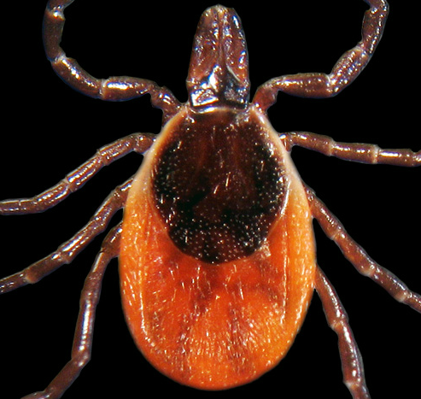

11. 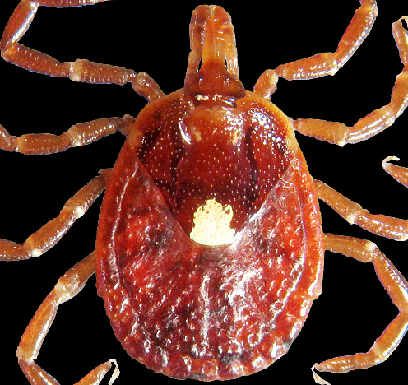

12. 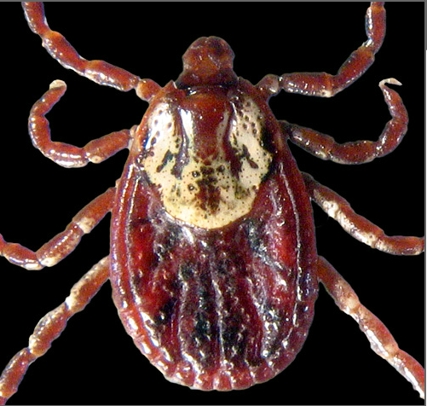

Multiple Choice:

13. What are life stages for a tick?
A) egg, worm, adult
B) egg, nymph, adult
C) egg, larva, nymph, adult
D) egg, worm, larva, adult

14. How long does their life cycle take?
- 10 years
- 6 months
- 10-12 months
- 2-3 years

15. How do ticks find their hosts?
- see them coming and jump onto host
- sense heat or vibration and climb onto a host that brushes by them
- climb up trees and fall onto hosts walking under
- fly around looking for hosts to attack

16. Most tick-borne diseases are what type of pathogen?
- bacteria
- virus
- protozoa
- fungus

17. What are typical symptoms of tick-borne disease?
- fever, welt where bite is located, rash
- fever, headache and muscle aches, sometimes rash
- joint pain, rash, open ulcers on skin
- anemia, paralysis, rash

18. How do doctors diagnose a tick-borne disease?
- Blood samples (look for pathogen)
- PCR (look for pathogen DNA)
- IFA, Western-Blot, ELISA (look for antibodies)
- All of the above

19. What should you do to prevent tick-bites?
- never go outside
- stay out of long grass, wear long pants and use DEET
- don’t have a dog or cat
- don’t climb trees or travel

20. What is causing the increase in tick-borne diseases?

- increase in number of deer in the US
- ticks are mutating to carry more disease
- more people have pets (dogs and cats)
- all of the above

Short answer / Reflection Questions:

1. What is something you learned about ticks that you didn’t know before this unit?

2. How will you use this information that you learned?

3. What behaviors will you change because of this unit?

