Spatial Epidemiology of Tick-Borne Disease
Using the case reports published by the state health department, design a graph that illustrates the incidence of tick-borne disease in the state of Kansas since 2012. Your graph should include axes labels, a title, a key (if necessary) and a caption that describes the data.

Calculate the rate of change from year to year for each of the tick-borne diseases shown in your graph.

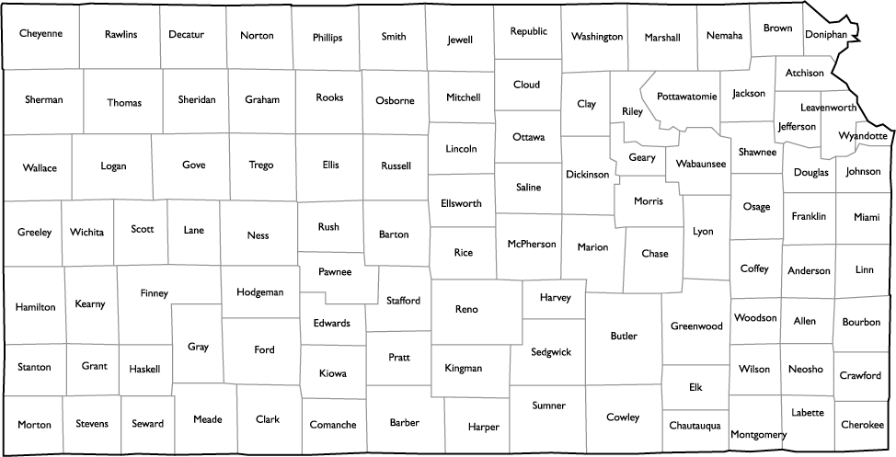

Use the county by county data to generate a spatial epidemiological map that indicates the counties affected by TBD so far this year.

Describe the data and propose an explanation for why these counties are affected.

